### Project Documentation: Network Configuration with Two VLANs on a Switch and Router

#### 1. ****Topology Description****

This project involves setting up a basic network with two VLANs (VLAN 10 and VLAN 20) on a single switch. Routing between VLANs is performed using a router. The topology includes the following devices:

* **Router** (Cisco 2811), responsible for routing between VLANs.
* **Switch** (Cisco 2960), supporting two VLANs and providing connectivity between PCs and the router.
* **Two computers** (PC1 and PC2), each connected to a different VLAN.

The topology looks like this:

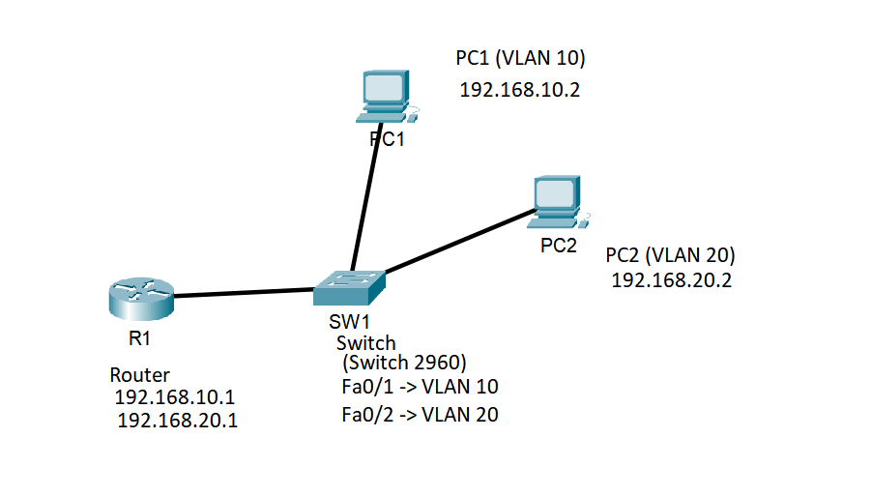

#### 2. ****Device Configuration****

**Router**  
On the router, configure two sub-interfaces for each VLAN using the dot1Q technology to tag the VLANs:

* **Sub-interface for VLAN 10**: Gig0/0.10 with IP address 192.168.10.1
* **Sub-interface for VLAN 20**: Gig0/0.20 with IP address 192.168.20.1

Router Configuration:

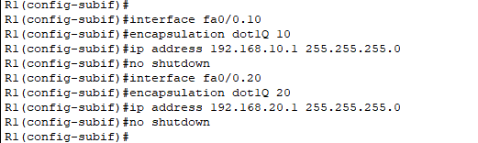

**Switch**  
On the switch, configure two VLANs:

* **VLAN 10** for PC1.
* **VLAN 20** for PC2.

Also, configure a trunk port to connect to the router.

**Switch Configuration:**

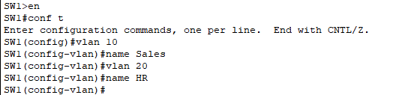

* **Assign VLANs to interfaces:**

For port Fa0/1 (connected to PC1, VLAN 10):

For port Fa0/2 (connected to PC2, VLAN 20):

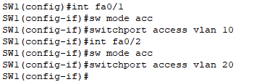

Configure trunk port (Fa0/24):



**On the Router:**

* **Creating sub-interfaces for each VLAN:**

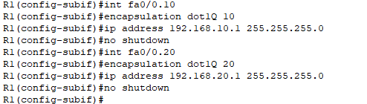

#### 4. ****IP Address Configuration on PCs****

**PC1:**

* IP: 192.168.10.2
* Gateway: 192.168.10.1
* Subnet Mask: 255.255.255.0

**PC2:**

* IP: 192.168.20.2
* Gateway: 192.168.20.1
* Subnet Mask: 255.255.255.0

1. **Screenshots of Device Configurations**

Screenshots of ping tests between PC1 and PC2.

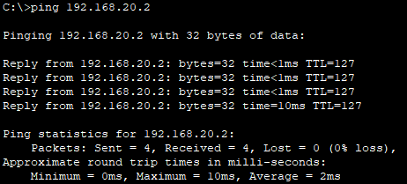

Screenshot of IP address settings on PCs.

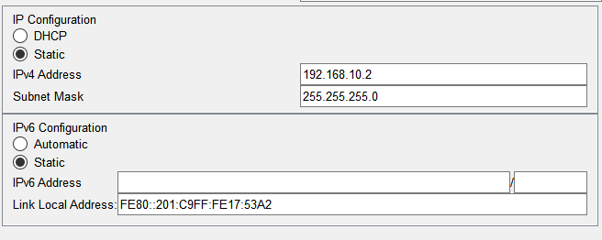

PC2:

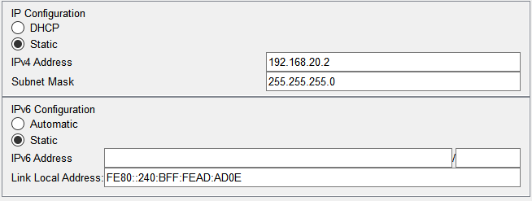

Switch(SW1):

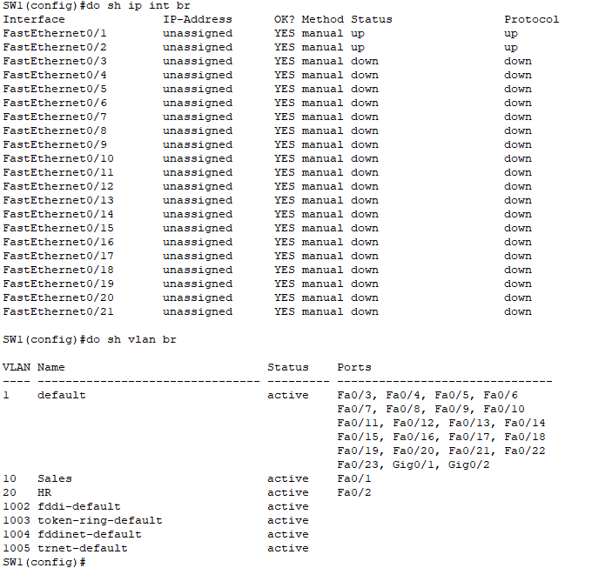

Router(R1):

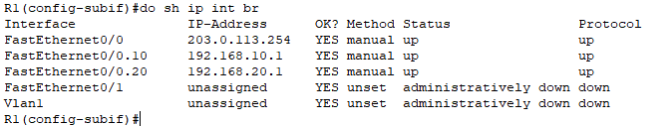

#### 6. ****Testing****

Test the connectivity between the PCs:

* On **PC1**, ping PC2:



#### 7. ****Conclusion****

By completing this project, a simple network with two VLANs was configured, allowing traffic to route between the VLANs using a router. Each computer received an IP address based on the VLAN to which it was connected, and both PCs successfully pinged each other through the router, confirming the configuration was successful.